3.

Navigation: Purchasing Responsibility> Supply Base > Suppliers > Address book

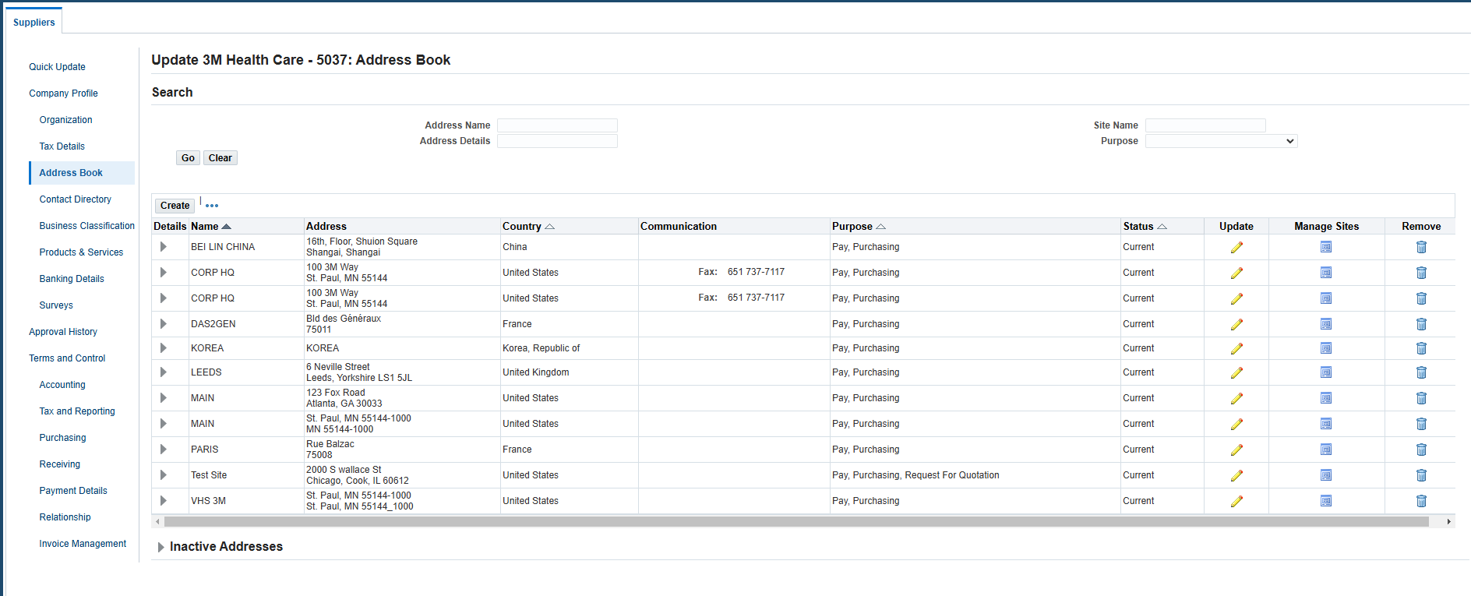

4. Payment Details:

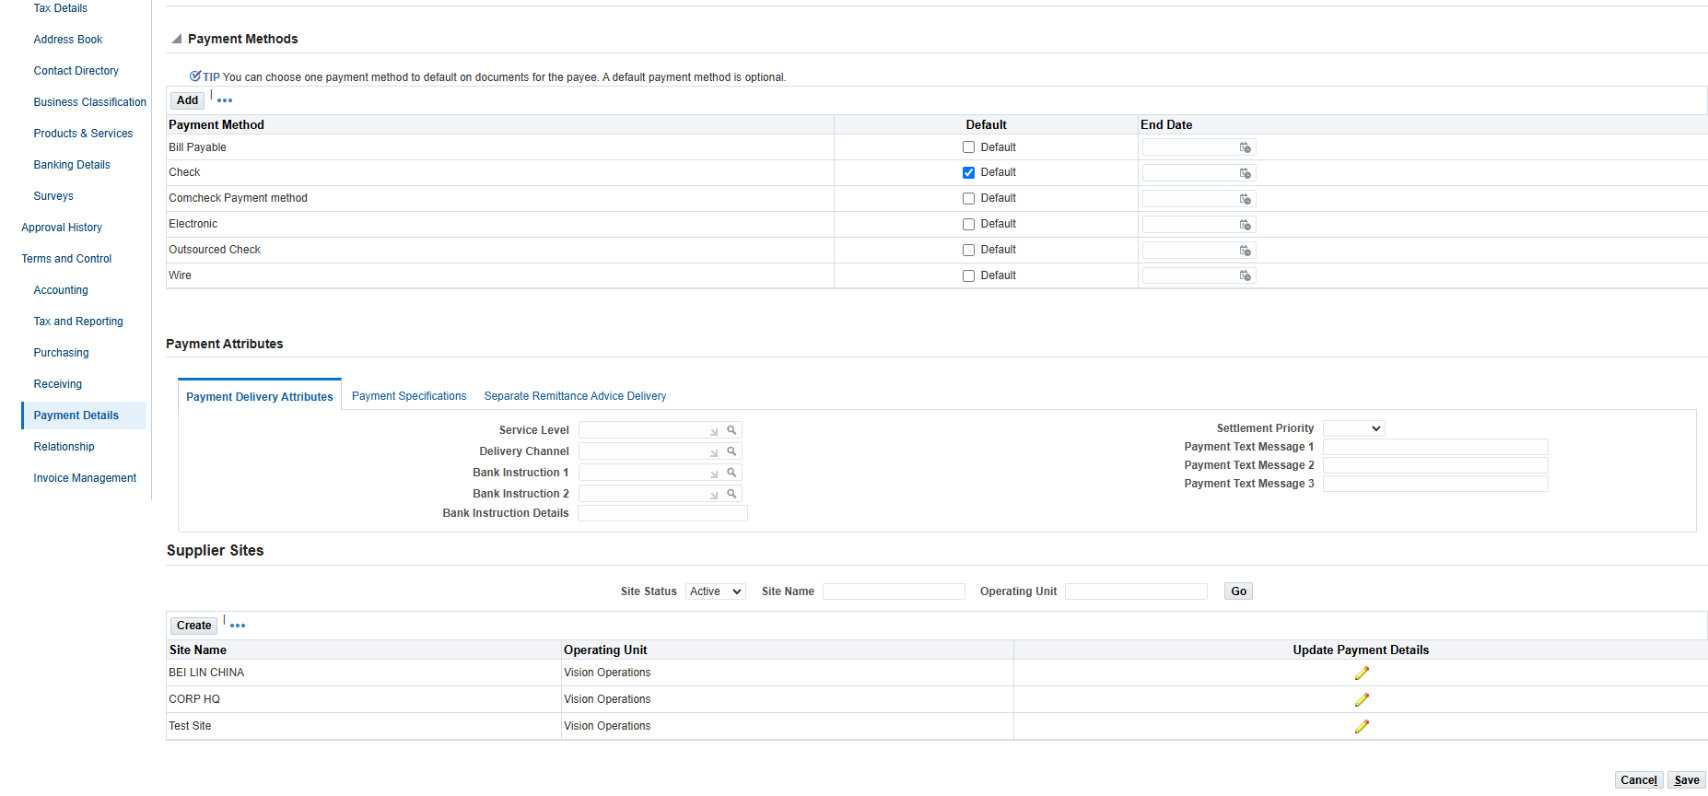

Banking Details:

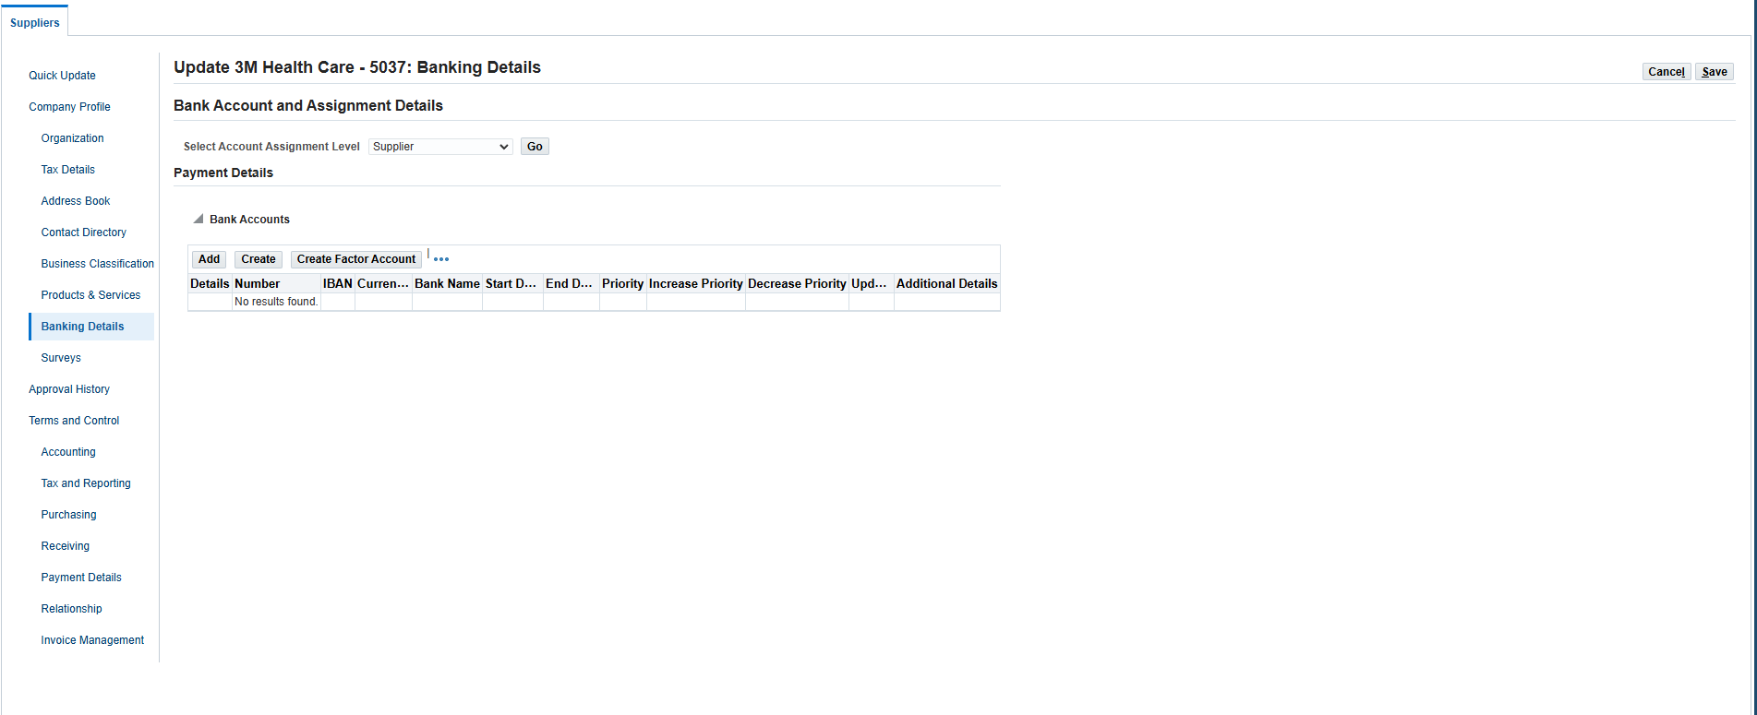

5. Navigation: Purchasing Responsibility> Requisitions> Requisitions> CTRL + FN + F11 > Type in the requisition number in the number portion.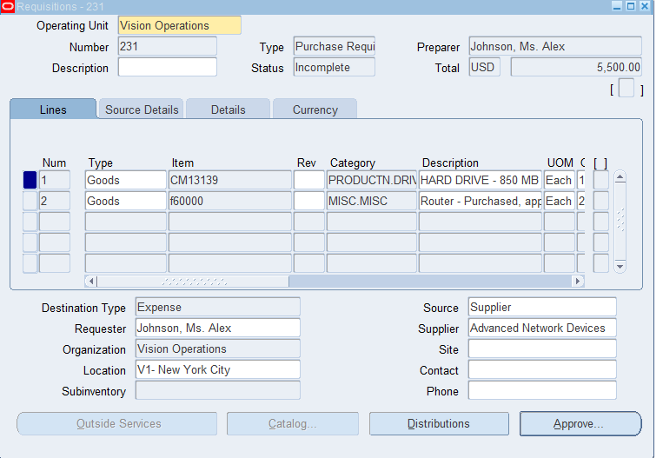

6. Navigation: Purchasing Responsibility>Purchase Order > Purchase Order> Ctrl +fn +f11>search for your query>CTRL+F11

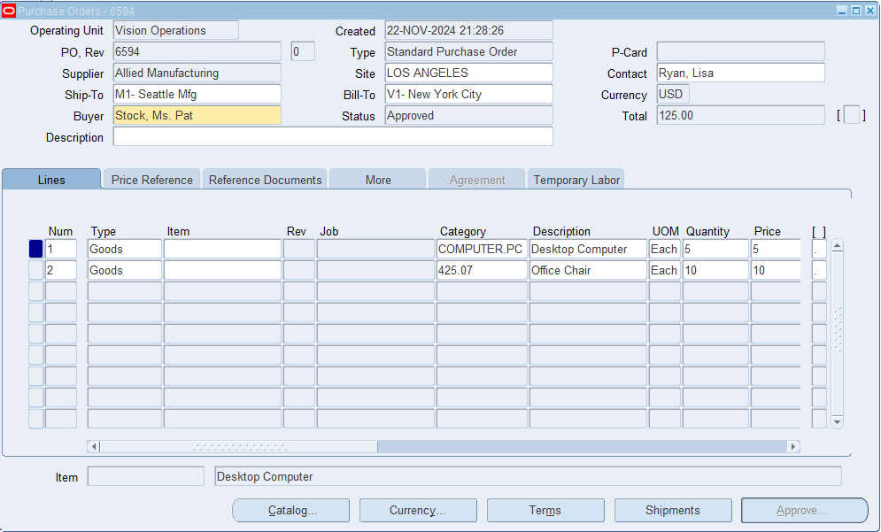

7.

* Oracle Purchasing:
  + Manages the creation, approval, and tracking of purchase orders (POs).
* Oracle iProcurement:
  + Provides a self-service portal for employees to create and manage purchase requisitions.
* Oracle Sourcing:
  + Streamlines the supplier sourcing and RFQ process
* Oracle iSupplier Portal:
  + Enables suppliers to access and manage their information and transactions online.
* Oracle Procurement contracts:
  + Manages the creation and maintenance of procurement contracts.
* Oracle supplier Lifecycle Management (SLM):
  + Focused on managing supplier onboarding, qualifications, and performance.

10. The key configuration for Procurement/Purchasing in Oracle EBS involves setting up the foundational elements required to enable the procurement processes.

* Define financial Options
  + Setup>Organizations>Financial Options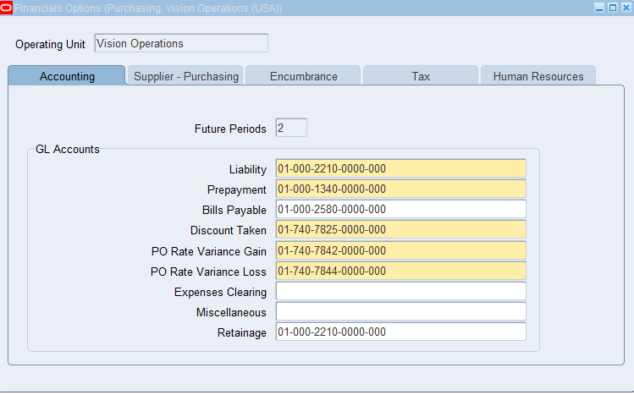
* Define purchasing Options
  + Setup>Organizations>Purchasing Options
  + 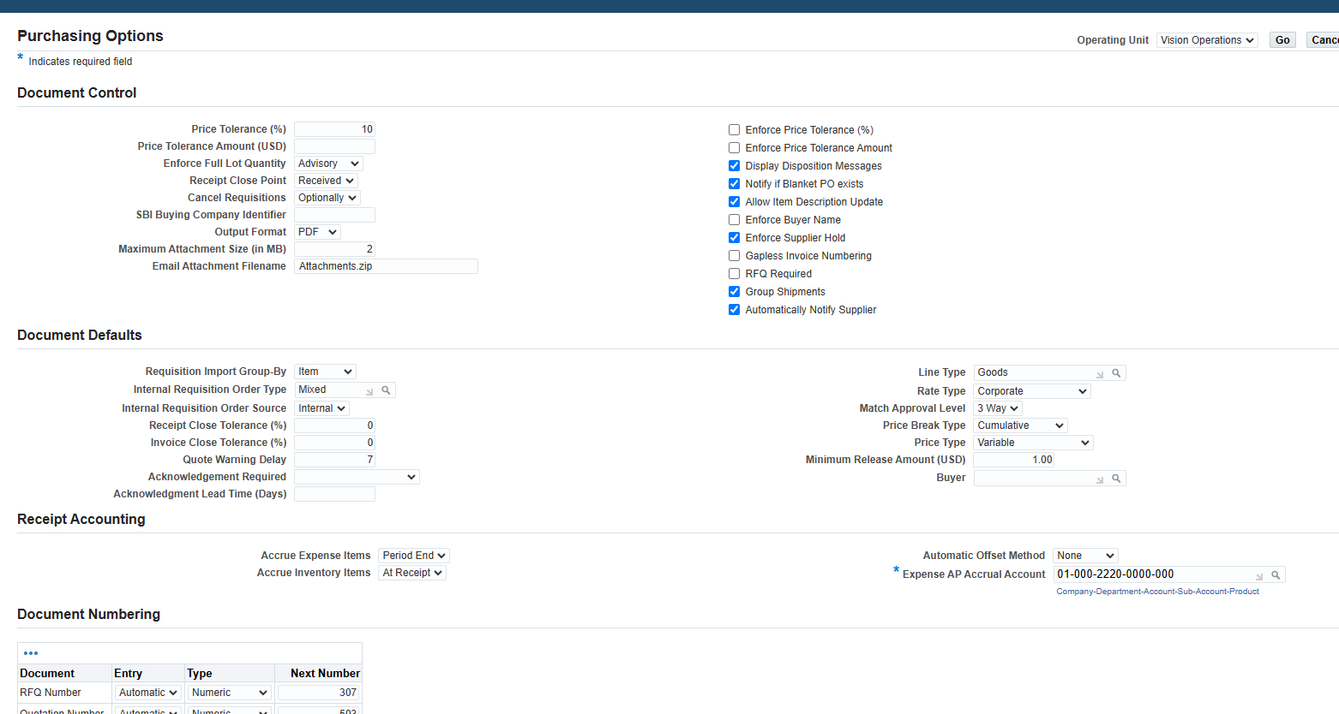
* Define Receiving Options
  + Setup>Organizations>Receiving Options
  + 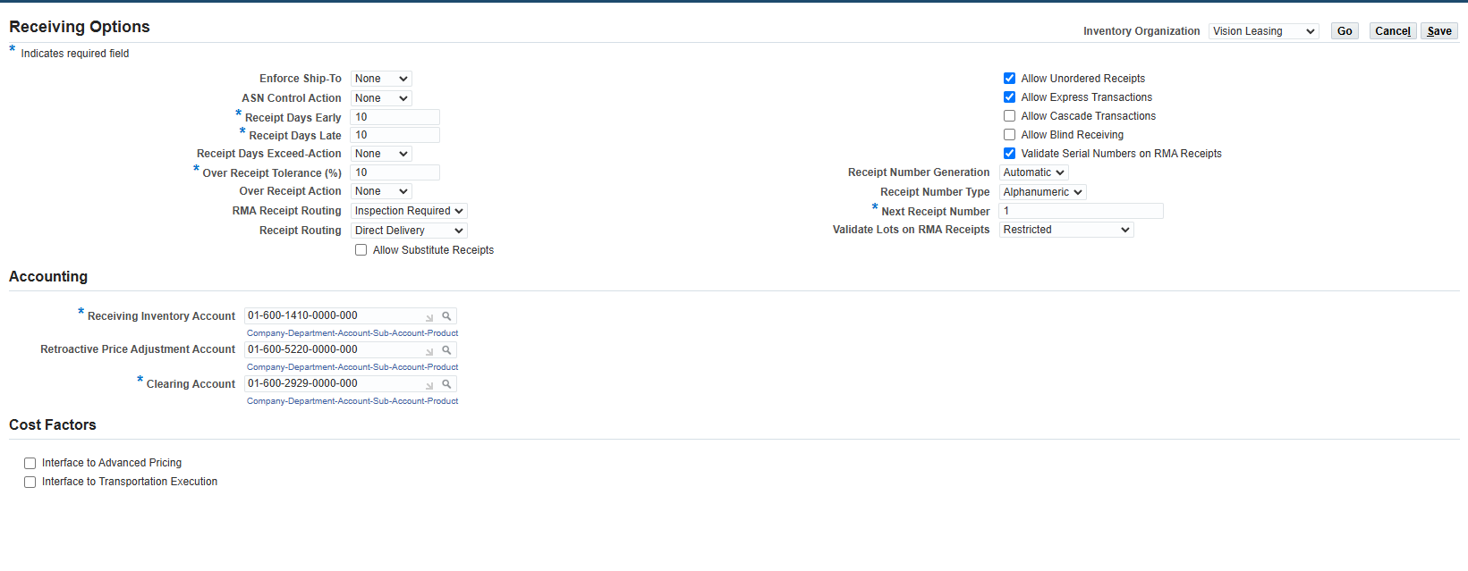
* Create and assign locations
  + Setup>Organizations>Locations
  + 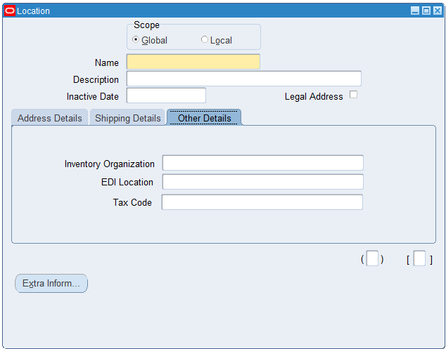
* Set up Approval Hierarchies
  + Setup>Approvals>Approval Groups
  + 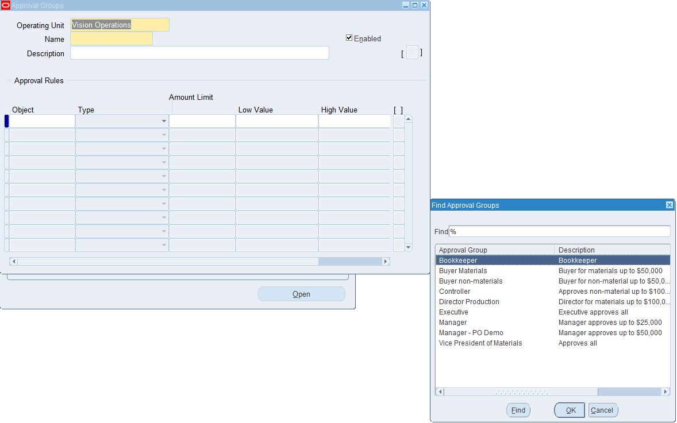
* Define Suppliers and Supplier Sites
  + **Supply Base** → **Suppliers**
  + 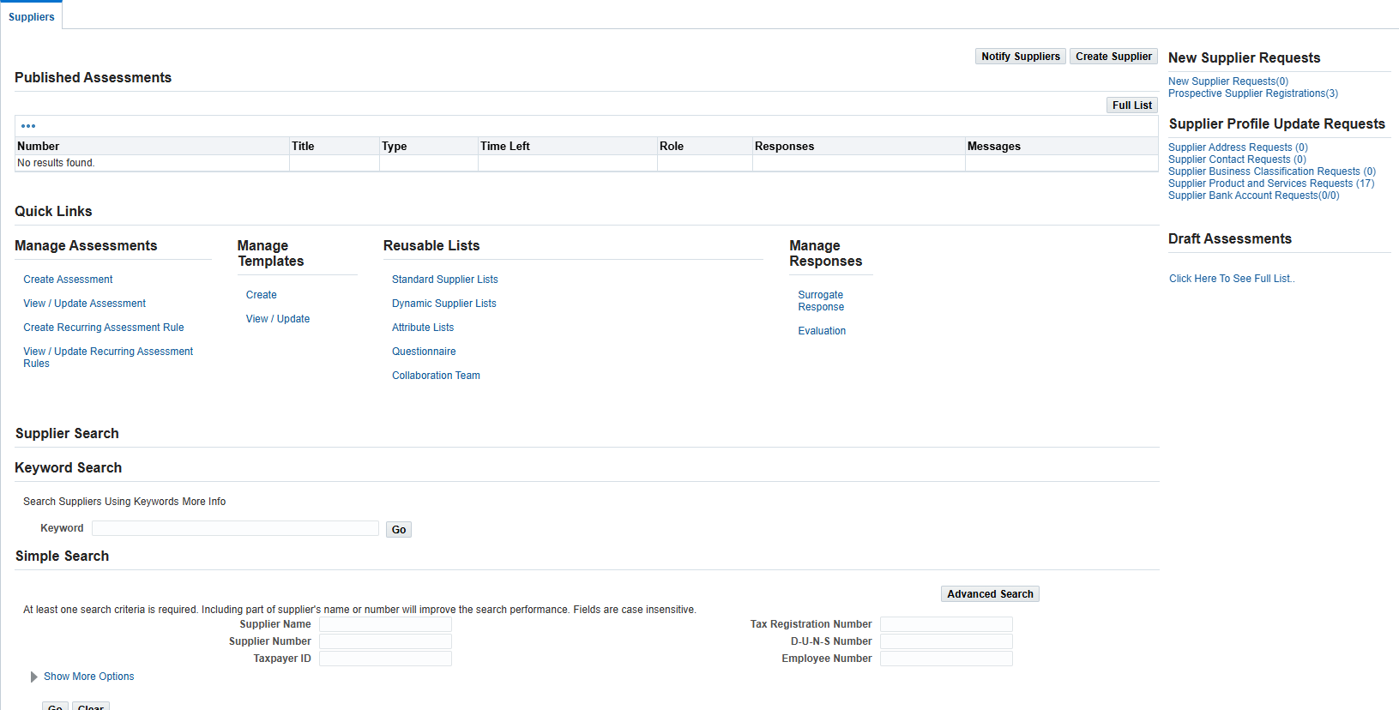
* Define items and item categories
  + **Inventory Responsibility** → **Items** → **Master Items**
  + 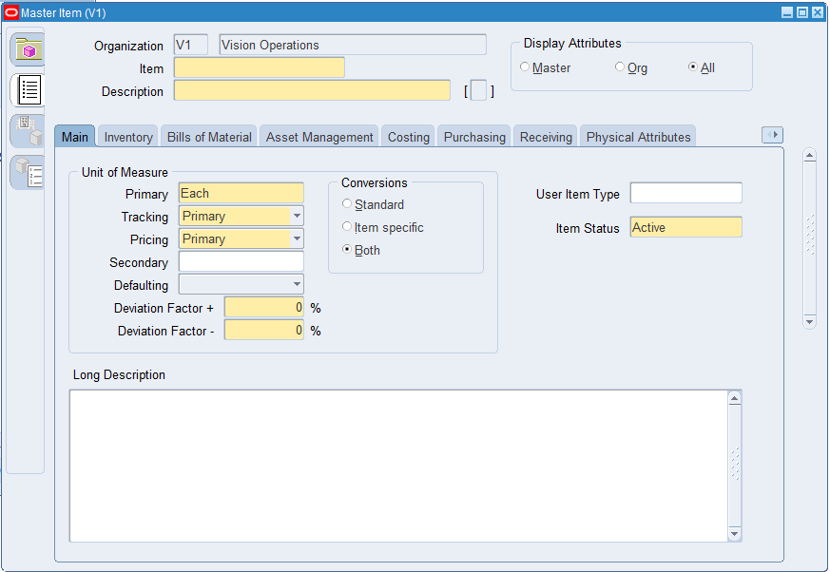
* Set up Document Type and Numbering
  + **Setup** → **Purchasing** → **Document Types**
  + 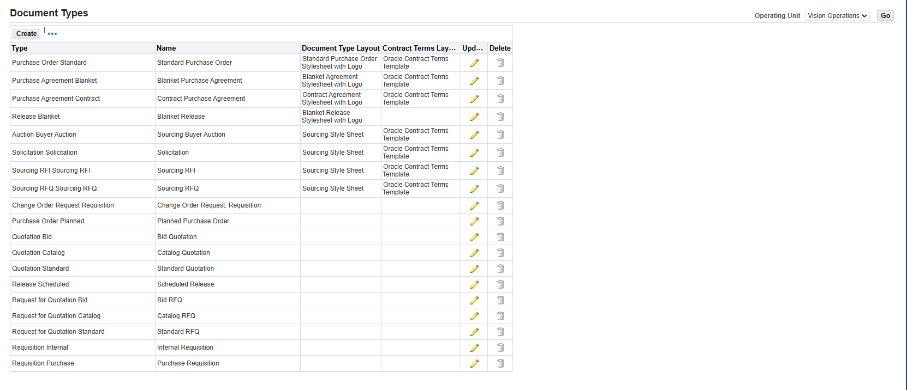
* Set up Inventory Organizations
  + **Inventory Responsibility** → **Setup** → **Organizations** → **Organizations**
  + 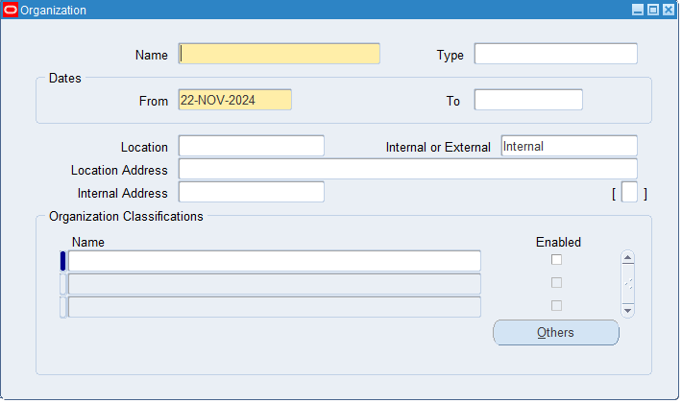

**11.**

* Requisition
  + Requisitions>Requisitions
  + 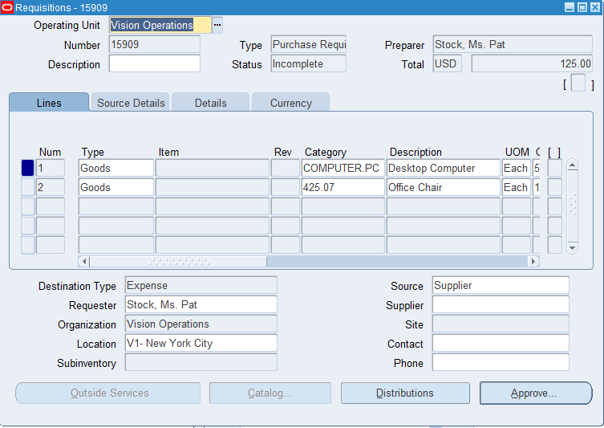
* Purchase Order
  + Purchase Orders> Purchase Orders Summary
  + Purchase Orders > Purchase Orders
  + 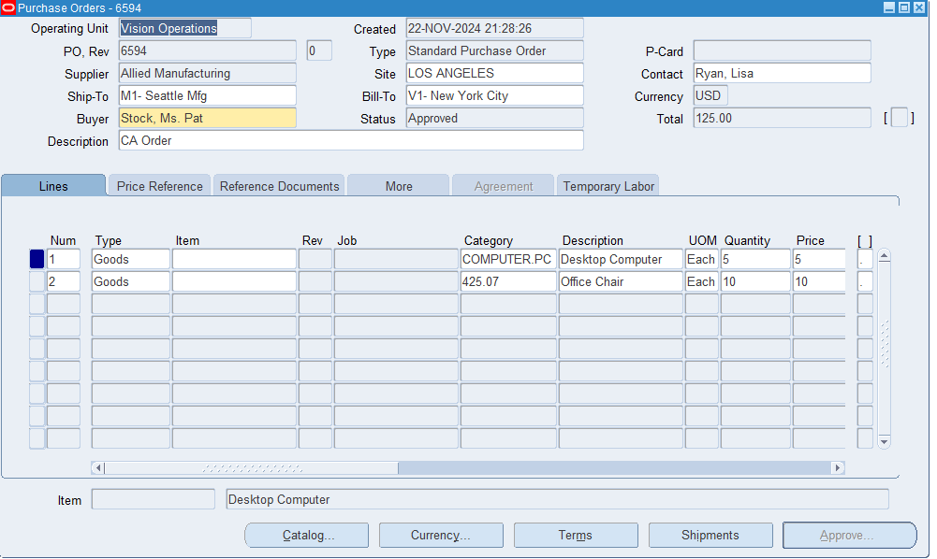
* Receipt for PO
  + Receiving> Receiving Transactions Summary
  + 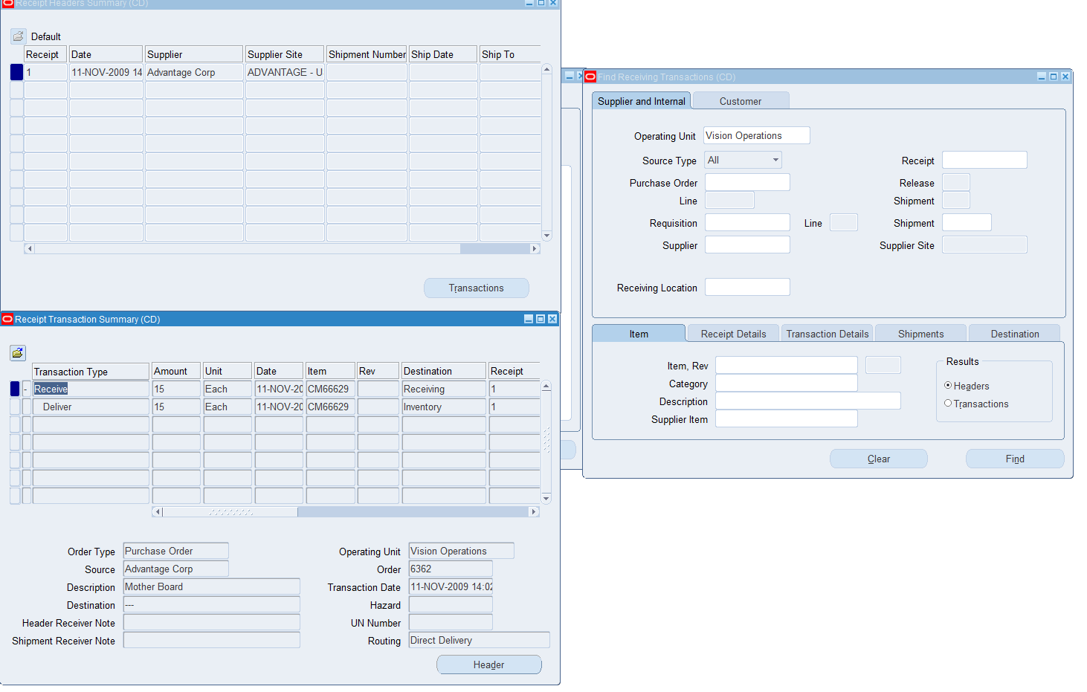

12.

Create a requisition> Requisitions>Requisitions

Fill out requirements: 5 Desktop Computers, 10 Office Chairs 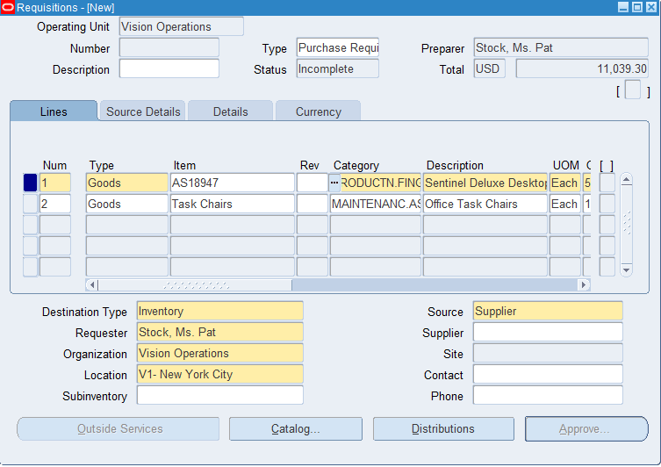

Save -> note down Requisition Number -> Approve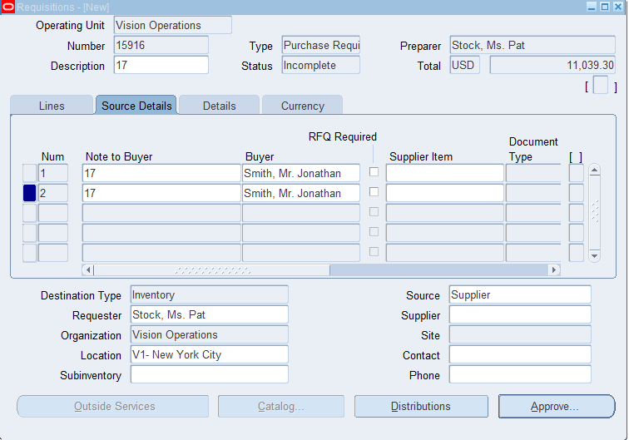

AutoCreate and find the lines for your requisition

Create a Purchase Order and approve purchase order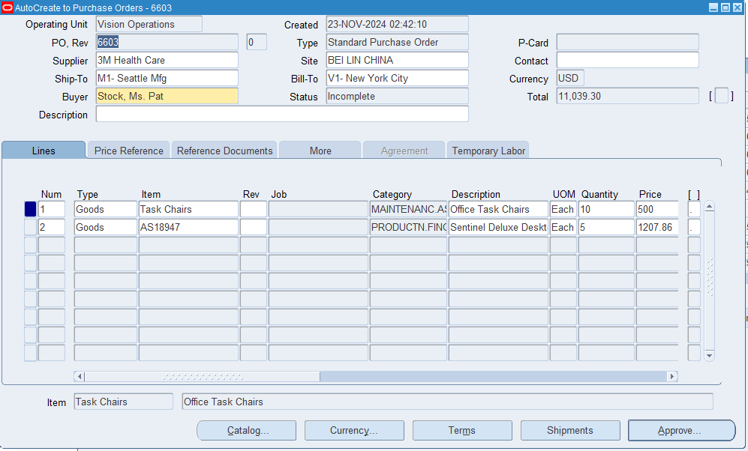

Communicate PO to supplier. Requests>Submit a new request> PO Output for Communication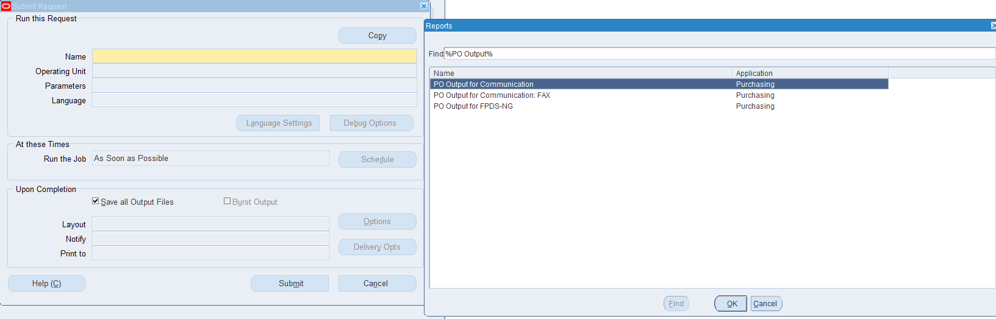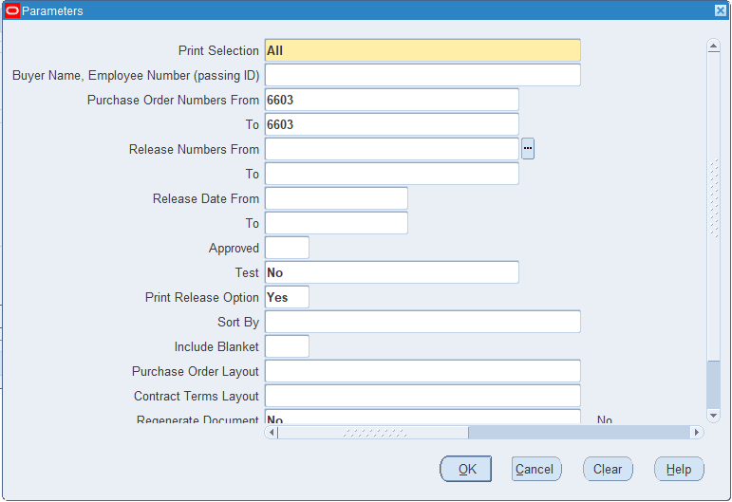

13. Create a Supplier:

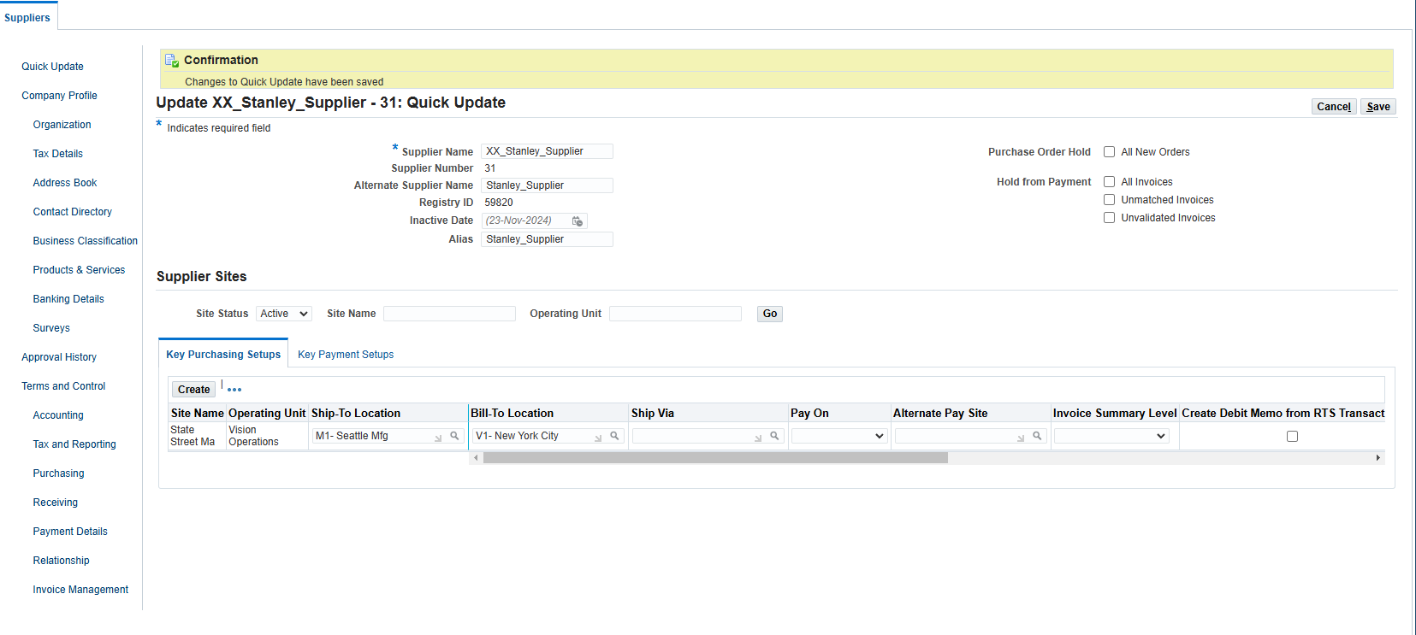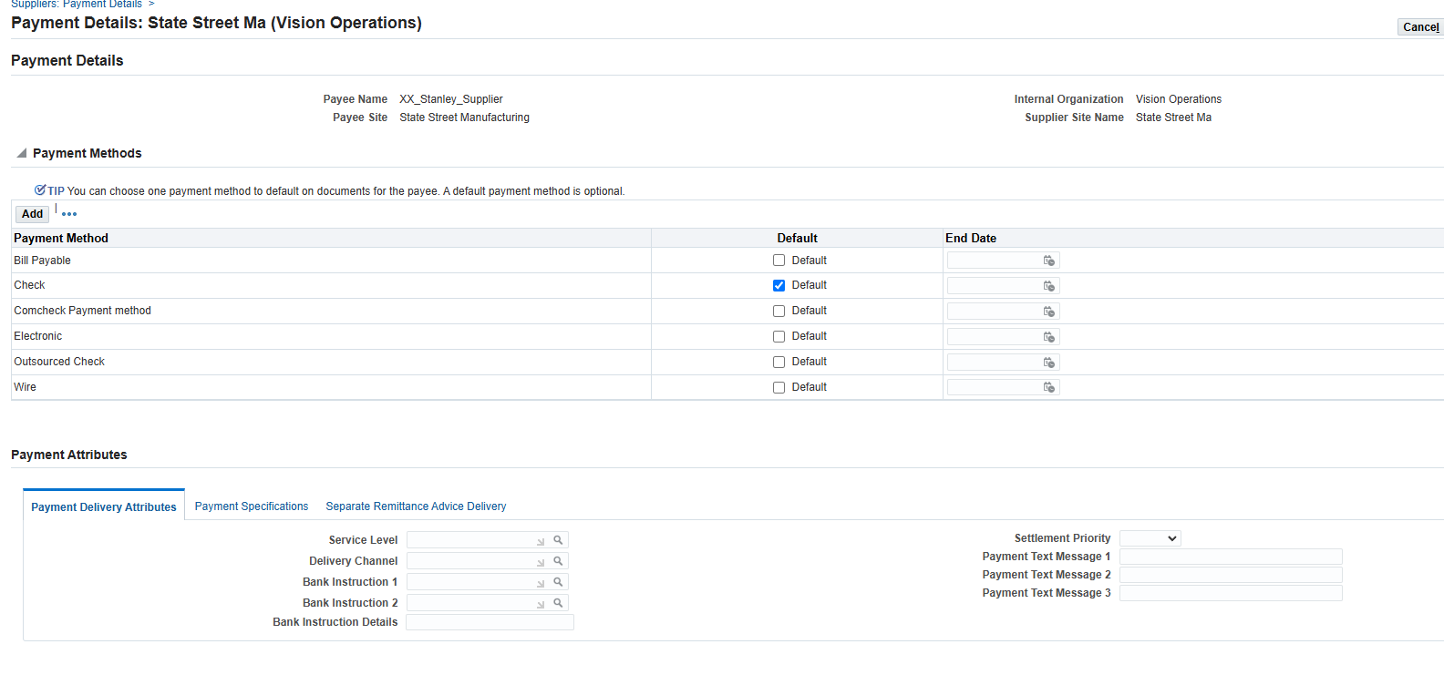

14. Create a Requisition:

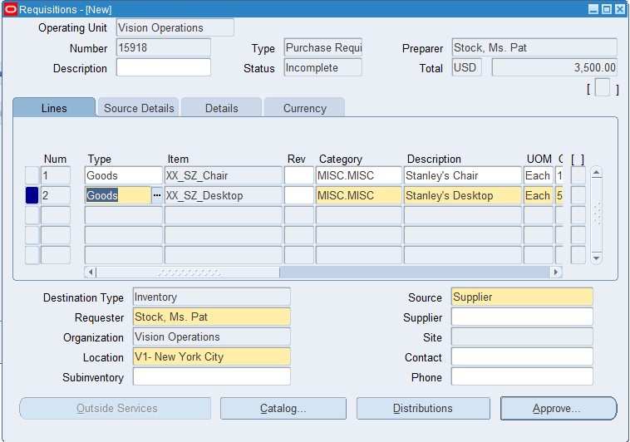

15. Create a Purchase Order: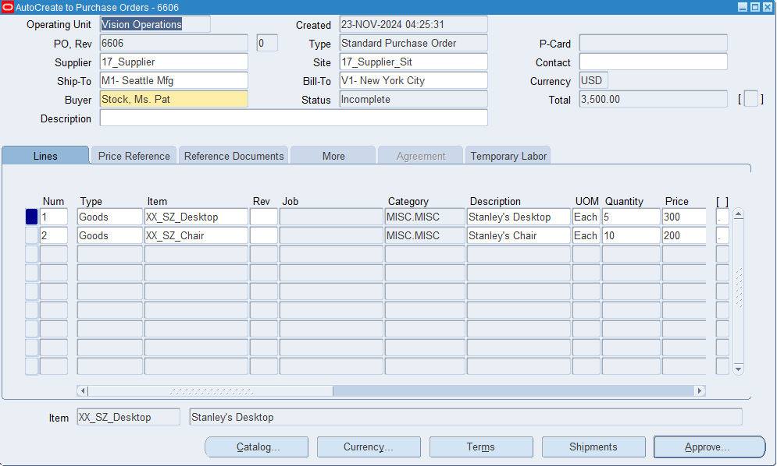

16. Create a Quotation:

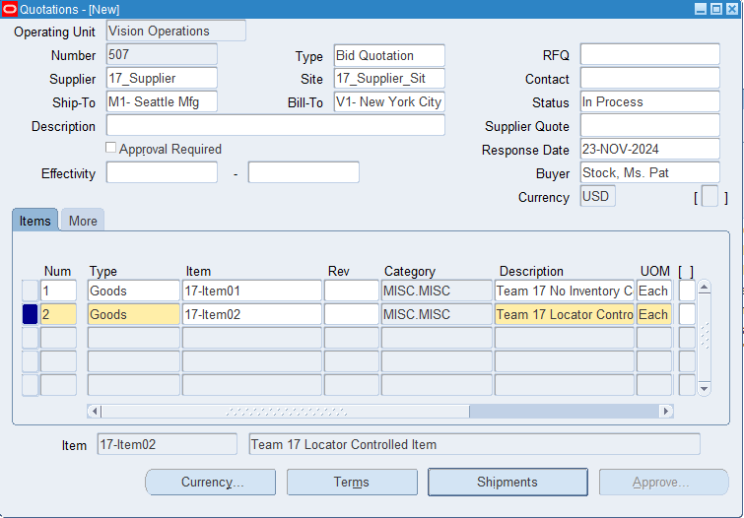

17. Setup>Financial Options